A PROJECT REPORT ON SMART HEALTH RISK PREDICTOR SYSTEM

SUBMITTED TO
JAWAHARLAL NEHRU TECHNOLOGICAL UNIVERSITY, KAKINADA

In the partial fulfilment of the requirements for the award of the degree of

BACHELOR OF TECHNOLOGY
IN
ARTIFICIAL INTELLIGENCE AND DATA SCIENCE
Submitted by
CHALAMALA REVATHI 22NG1A5409
AVUTHU KALYANI 22NG1A5404
GALLA TARUN 22NG5A5416
PEDDINTI BHARATHI 22NG1A5449
Under the Esteemed Guidance of
M. CHAITANYA
Assistant Professor
DEPARTMENT OF ARTIFICIAL INTELLIGENCE


AUTONOMOUS
(Approved by AICTE and JNTUK, Kakinada)
(ON NH 16, TELAPROLU, NEAR GANNAVARAM - 521109)

2022-2026

AUTONOMOUS

Vision of the Institute

To emerge as a Centre of excellence in technical education by imparting quality teaching learning practices and research for the transformation of society.

Mission of the Institute

M1: Provide an ideal and the best class infrastructure to foster exploration in engineering and research

M2: Build dedicated faculty with student centric teaching, incorporating experiential, innovative skills.

M3: Encourage life-long learning, entrepreneurial thinking, and ethical responsibility in students to address societal challenges.

AUTONOMOUS

DEPARTMENT OF ARTIFICIAL INTELLIGENCE

Vision of the Department

To emerge as a skilled Technocrats on global scale in Artificial Intelligence and Data Science through quality education, innovation, collaborative researchers and entrepreneurs with moral values.

Mission of the Department

M1: To impart quality education to the students.
M2: To pursue creative research and new technologies in Artificial Intelligence and Data Science.
M3: To encourage entrepreneurship skills among students and inculcate moral and ethical values to serve society.

Department Program Educational Objectives (PEOs)

PEO1: Our graduates will establish themselves as effective professionals in industry, academia and entrepreneurship.
PEO2: Our graduates will become profound researchers in multiple domains.
PEO3: Our graduates will act as leaders in society.

Department Program Specific Outcomes (PSOs)

PSO1: Illustrating a comprehensive understanding of fundamental computer system principles encompassing both hardware and software components to cultivate strong conceptual skills in processing and assigning computation solutions.

PSO2: Demonstrate and design proficient and technical abilities in algorithms, networking, web design, cloud computing and data analytics enabling the development of innovative solutions to complex real-world problems while identifying and addressing emerging research gaps

AUTONOMOUS

Program Outcomes (POs)

PO1: Engineering Knowledge: Apply knowledge of mathematics, natural science, computing, engineering fundamentals and an engineering specialization.

PO2: Problem Analysis: Identify, formulate, review research literature and analyze complex engineering problems reaching substantiated conclusions with consideration for sustainable development.

PO3: Design/Development of Solutions: Design creative solutions for complex engineering problems and design/develop systems/components/processes to meet identified needs with consideration for the public health and safety, whole-life cost, net zero carbon, culture, society and environment as required.

PO4: Conduct Investigations of Complex Problems: Conduct investigations of complex engineering problems using research-based knowledge including design of experiments, modelling, analysis & interpretation of data to provide valid conclusions.

PO5: Engineering Tool Usage: Create, select and apply appropriate techniques, resources and modern engineering & IT tools, including prediction and modelling recognizing their limitations to solve complex engineering problems.

PO6: The Engineer and The World: Analyze and evaluate societal and environmental aspects while solving complex engineering problems for its impact on sustainability with reference to economy, health, safety, legal framework, culture and environment.

PO7: Ethics: Apply ethical principles and commit to professional ethics, human values, diversity and inclusion; adhere to national & international laws.

PO8: Individual and Collaborative Team work: Function effectively as an individual, and as a member or leader in diverse/multi-disciplinary teams.

PO9: Communication: Communicate effectively and inclusively within the engineering community and society at large, such as being able to comprehend and write effective reports and design documentation, make effective presentations considering cultural, language, and learning differences

PO10: Project Management and Finance: Apply knowledge and understanding of engineering management principles and economic decision-making and apply these to one’s own work, as a member and leader in a team, and to manage projects and in multidisciplinary environments.

PO11: Life-Long Learning: Recognize the need for and have the preparation and ability for i) independent and life-long learning ii) adaptability to new and emerging technologies and iii) critical thinking in the broadest context of technological change.

AUTONOMOUS

DEPARTMENT OF ARTIFICIAL INTELLIGENCE

CERTIFICATE

This is to certify that this Project Work entitled “SMART HEALTH RISK PREDICTOR SYSTEM” is the Bonafide work of CHALAMALA REVATHI (22NG1A5409), AVUTHU KALYANI (22NG1A5404), GALLA TARUN (22NG1A5416), PEDDDINTI BHARATHI (22NG1A5449) who carried out the work under my supervision and submitted in partial fulfilment of the requirements for the award of the degree in Bachelor of Technology in Artificial Intelligence and Data Science during the academic year 2024-2025.

Project Guide Head of the Department
M. CHAITANYA Dr. K.P.N.V. SATYA SREE
Assistant Professor Professor

DECLARATION

We hereby declare that the Project Work entitled “SMART HEALTH RISK PREDICTOR SYSTEM” is the work done by us during the academic year 2024-2025 and is submitted in partial fulfilment of the requirements for the award of degree of Bachelor of technology in ARTIFICIAL INTELLIGENCE AND DATA SCIENCE from JAWAHARLAL NEHRU TECHNOLOGICAL UNIVERSITY, KAKINADA.

BY
CHALAMALA REVATHI 22NG1A5409
AVUTHU KALYANI 22NG1A5404
GALLA TARUN 22NG5A5416
PEDDINTI BHARATHI 22NG1A5449

ACKNOWLEDGEMENT

We are pleased to acknowledge our sincere thanks to our Honorable Chairman SRI. S. RAMABRAHMAM for the support and encouragement which is given and for providing sufficient resources.
We wish to avail this opportunity to express our thanks to Dr. G. V. K. S. V PRASAD, Principal, URCE, for his continuous support and giving valuable suggestions during the entire period of the Project Work.

We are taking this opportunity to express our gratitude to Dr. K. P. N. V. SATYA SREE, Head of the Department, and my guide M. CHAITANYA, Assistant Professor in Computer Science and Engineering, for their valuable support and motivation at every point in successful completion of the Project Work.

We also place our floral gratitude to all other teaching staff and lab technicians for their constant support and advice throughout the Project Work.

BY
CHALAMALA REVATHI 22NG1A5409
AVUTHU KALYANI 22NG1A5404
GALLA TARUN 22NG5A5416
PEDDINTI BHARATHI 22NG1A5449

SMART HEALTH RISK PREDICTOR SYSTEM

ABSTRACT

Health risk prediction is increasingly important for preventive healthcare and early disease detection. The Smart Health Risk Predictor System leverages machine learning algorithms to analyse medical and lifestyle data, including age, BMI, blood pressure, glucose levels, cholesterol, and activity patterns, to assess an individual's risk of developing health issues. By classifying users into low, medium, or high-risk categories, the system provides actionable insights for both individuals and healthcare professionals. The platform features a user-friendly interface that allows real-time input and prediction, supporting timely interventions and promoting proactive health management.
Health risk prediction plays a vital role in early disease detection and preventive healthcare. Traditional health assessment methods rely on manual analysis by medical professionals, which can be time-consuming and may not efficiently handle large volumes of patient data. With the increasing availability of health and lifestyle data, Machine Learning provides powerful techniques to analyze patterns and predict potential health risks at an early stage.
This project presents a Smart Health Risk Predictor System that uses Machine Learning techniques to predict an individual’s health risk level based on medical and lifestyle parameters such as age, gender, BMI, blood pressure, glucose levels, cholesterol, smoking habits, and physical activity. The system classifies users into different risk categories such as low, medium, or high risk.
The model is trained using supervised machine learning algorithms and evaluated using standard performance metrics. A user-friendly web interface is developed using Streamlit, allowing users to enter their health details and instantly receive health risk predictions. The proposed system supports preventive healthcare by enabling early diagnosis, improving awareness, and assisting healthcare professionals in decision-making.

Table of Contents

CHAPTERS | TOPICS | Page No.
CHAPTER 1 | Introduction  - Overview of Health Risk Prediction Systems  1.2 Importance of Automation in Healthcare  1.3 Role of Machine Learning in Healthcare | 1
CHAPTER 2 | Problem Definition  - Limitations of Traditional Health Assessment Methods  - Challenges in Existing Health Prediction Systems  - Need for Intelligent Health Risk Prediction | 2
CHAPTER 3 | Objectives of the Project  - Primary Objectives  - Secondary Objectives  - Expected Outcomes  Literature Review | 3
CHAPTER 4 | 4.1 Review of Existing Health Risk Prediction Methods  4.2 Machine Learning Models in Healthcare  4.3 Predictive Analytics in Healthcare | 4
CHAPTER 5 | System Requirements  - Hardware Requirements  - Software Requirements  - Tools and Technologies Used | 5
CHAPTER 6 | Dataset Description  - Source of Dataset  - Features and Attributes  - Target Variable Description | 6
CHAPTER 7 | Data Preprocessing  - Data Cleaning  - Handling Missing Values  - Encoding Categorical Variables  - Train–Test Split | 7
CHAPTER 8 | Machine Learning Methodology  - Model Selection (Gradient Boosting)  - Model Training Process  - Performance Evaluation Metrics | 8
CHAPTER 9 | Explainable ML Approach  - Importance of Explainability  - Gradient Boosting Interpretability  - Feature Contribution Analysis | 9-10
CHAPTER 10 | System Architecture and Design  - Overall System Architecture  - Workflow Diagram  - Model Integration | 11
CHAPTER 11 | Implementation and Results  - Frontend Implementation using Streamlit  - Prediction Output and Confidence Score  - Result Analysis  - Input and Output Screens | 12-18
CHAPTER 12 | Conclusion and Future Scope  - Summary of the Project  - Key Achievements  - Future Enhancements | 19
Reference |  | 20
Course Outcomes & Program Outcomes |  | 21
Sustainable Development Goals |  | 21

CHAPTER 1:- INTRODUCTION

1.1 Overview of Health Risk Prediction Systems
Health risk prediction systems are designed to analyze medical and lifestyle data in order to estimate an individual’s risk of developing health-related problems. These systems use patient information such as age, BMI, blood pressure, glucose level, and habits to identify potential health risks. By analyzing patterns in historical health data, these systems help in early detection of diseases. Early prediction allows timely medical intervention and preventive care. Such systems play an important role in improving overall healthcare quality.

1.2 Importance of Automation in Healthcare
Automation in healthcare reduces manual effort and improves efficiency in medical decision-making. Automated systems can process large volumes of patient data quickly and accurately. This minimizes human errors and ensures consistent results. Automation also helps doctors focus more on patient care rather than data analysis. In health risk prediction, automation enables fast and reliable assessment of health conditions.

1.3 Role of Machine Learning in Healthcare
Machine Learning plays a key role in modern healthcare by enabling predictive analysis based on data patterns. ML models learn from historical health records to predict future health risks. These models can identify complex relationships between health parameters that are difficult to detect manually. Machine Learning improves accuracy and reliability in disease prediction. It supports doctors and healthcare systems in making informed decisions.
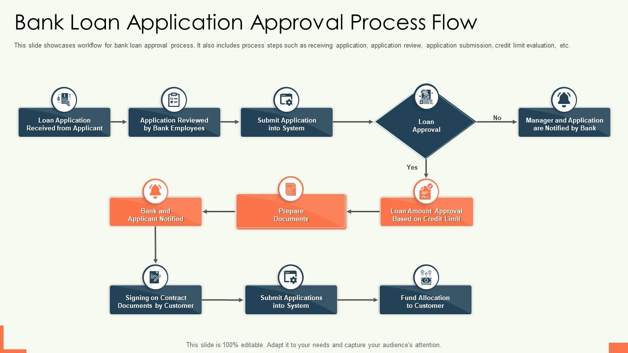
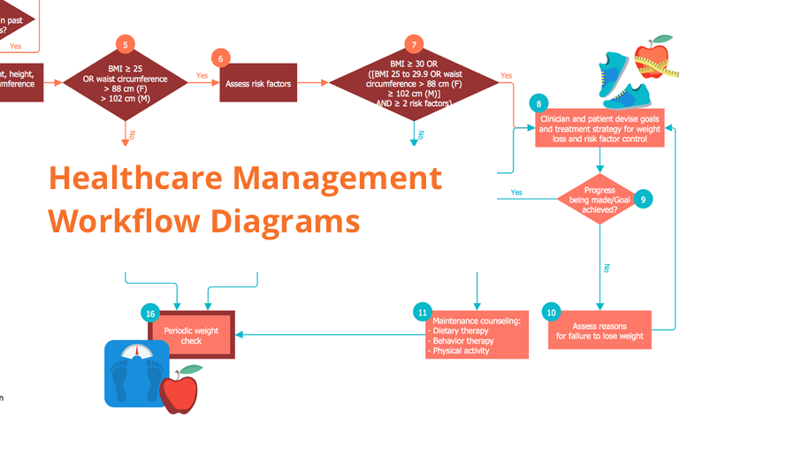

CHAPTER 2:- PROBLEM DEFINITION

2.1 Limitations of Traditional Health Assessment Methods
Traditional health assessment methods rely heavily on manual diagnosis and periodic medical checkups. These methods are time-consuming, inconsistent, and depend on individual judgment. They often fail to detect health risks at an early stage. Such approaches are not suitable for continuous and large-scale health monitoring.

2.2 Challenges in Existing Automated Health Prediction Systems
Although automated health prediction systems exist, many of them use complex models that act as black boxes. These systems provide predictions without clear explanations. This makes it difficult for doctors and users to understand the reasons behind the predicted health risk. Lack of transparency reduces trust and acceptance of such systems.

2.3 Need for Explainable Health Risk Prediction
In healthcare, transparency is critical because decisions directly affect human life. Patients and healthcare professionals expect clear explanations for predicted health risks. Explainable AI helps in understanding how medical and lifestyle factors influence predictions. This ensures fairness, accountability, and trust in healthcare decision-making.

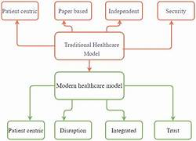

CHAPTER 3:- OBJECTIVES OF THE PROJECT

3.1 Primary Objectives
The primary objective of this project is to develop a Smart Health Risk Predictor System using Machine Learning that can accurately predict an individual’s health risk level while providing clear and understandable results.

3.2 Secondary Objectives
Secondary objectives include early detection of health risks, improving prediction accuracy, reducing manual health assessment effort, and providing confidence scores along with health risk predictions.

3.3 Expected Outcomes
The expected outcome is a reliable, accurate, and explainable health risk prediction system that supports preventive healthcare and increases user awareness and trust.

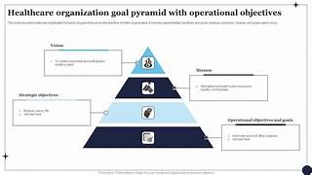

CHAPTER 4:- LITERATURE REVIEW

4.1 Review of Existing Health Risk Prediction Techniques
This section reviews traditional health assessment methods and rule-based systems used for predicting health risks. It highlights their limitations such as low accuracy, manual effort, and lack of scalability.

4.2 Machine Learning Models in Healthcare
Various machine learning models such as Logistic Regression, Decision Trees, Random Forests, and Neural Networks are discussed. Logistic Regression is commonly used due to its simplicity, efficiency, and interpretability in healthcare prediction.

4.3 Explainable AI in Healthcare Systems
This section reviews the use of Explainable AI in healthcare, emphasizing the importance of transparency and interpretability. Explainable models help doctors and users understand predictions and support ethical decision-making.
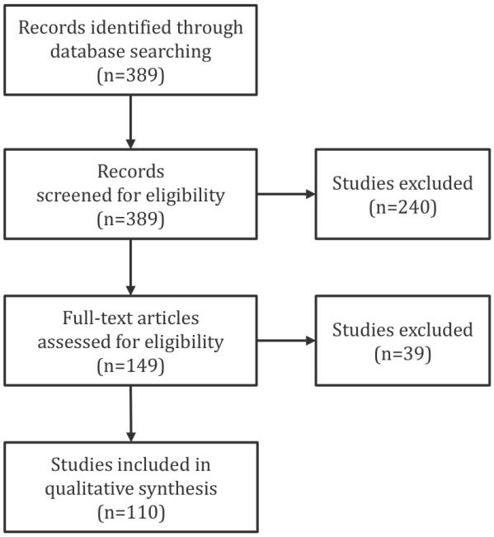

CHAPTER 5:- SYSTEM REQUIREMENTS

5.1 Hardware Requirements
A standard computer or laptop with a minimum of 4GB RAM, a basic processor, and sufficient storage is required to run the Smart Health Risk Predictor System efficiently.

5.2 Software Requirements
The required software includes Python, Jupyter Notebook or VS Code, Streamlit, and libraries such as Pandas, NumPy, Scikit-learn, and Pickle for data processing and model development.

5.3 Tools and Technologies Used
The project uses Python for system development, Scikit-learn for machine learning modeling, Streamlit for frontend development, and Git or local storage for version control.

CHAPTER 6:– DATASET DESCRIPTION

6.1 Source of Dataset
The dataset is obtained from publicly available healthcare sources such as Kaggle or from synthetic datasets designed to represent real-world health records.

6.2 Features and Attributes
The dataset includes features such as age, gender, BMI, blood pressure, glucose level, cholesterol, smoking habits, and physical activity.

6.3 Target Variable Description
The target variable represents the health risk level, which is classified as Low Risk, Medium Risk, or High Risk by the prediction model.

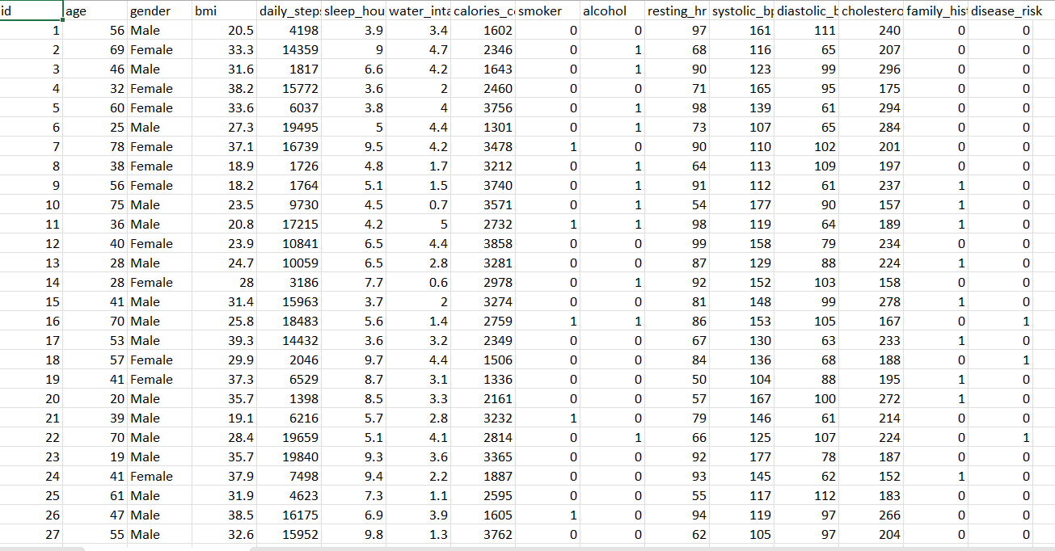

CHAPTER 7 – DATA PREPROCESSING

7.1 Data Cleaning
Data cleaning involves removing duplicate records, unnecessary columns, and correcting inconsistent data values.

7.2 Handling Missing Values
Missing values are handled using techniques such as mean, median, or mode replacement to maintain data consistency.

7.3 Encoding Categorical Variables
Categorical variables like gender and employment status are converted into numerical format using encoding techniques.

7.4 Train–Test Split
The dataset is split into training and testing sets, usually in an 80:20 ratio, to evaluate model performance fairly.

CHAPTER 8 – MACHINE LEARNING METHODOLOGY

8.1 Model Selection (Gradient Boosting Classifier)
The Gradient Boosting Classifier is selected due to its high accuracy, ability to handle complex data patterns, and strong performance in classification problems.

8.2 Model Training Process
The model is trained using the training dataset, where it learns patterns between input features and health risk outcomes.

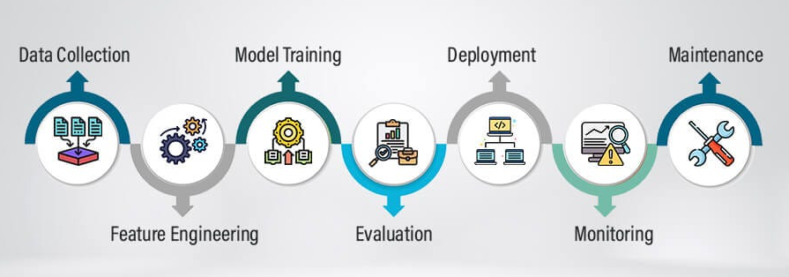

8.3 Performance Evaluation Metrics
Metrics such as accuracy, precision, recall, and F1-score are used to measure model effectiveness.

CHAPTER 9 – EXPLAINABLE ML APPROACH

9.1 Importance of Explainability
Explainability in machine learning is important to understand how and why a model makes a prediction. In healthcare systems, transparent predictions help build trust among users and doctors

9.2 Gradient Boosting Interpretability
Although Gradient Boosting is a powerful ensemble model, it can still be interpreted using feature importance techniques. These techniques show which input features have the highest impact on predictions

9.3 Feature Contribution Analysis
This analysis shows which features positively or negatively impact health risk decisions.
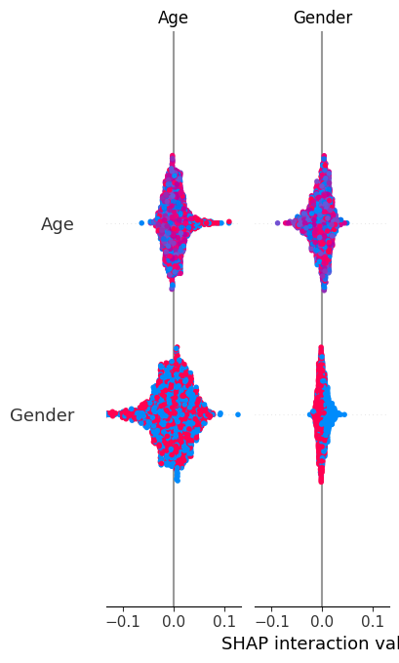

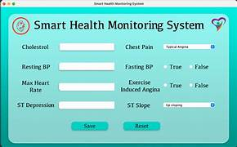

CHAPTER 10 – SYSTEM ARCHITECTURE AND DESIGN

10.1 Overall System Architecture
The system architecture includes user input, data preprocessing, ML model prediction, and result display.

10.2 Workflow Diagram
The workflow illustrates the step-by-step process from data input to final prediction.

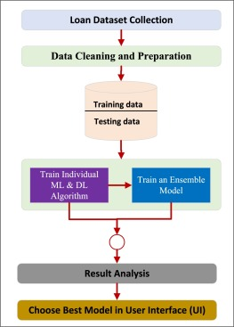

10.3 Model Integration
This section explains how the ML model is integrated with the frontend application.

CHAPTER 11 – IMPLEMENTATION AND RESULTS

12.1 Frontend Implementation using Streamlit
The frontend is developed using Streamlit, providing an interactive and user-friendly interface.

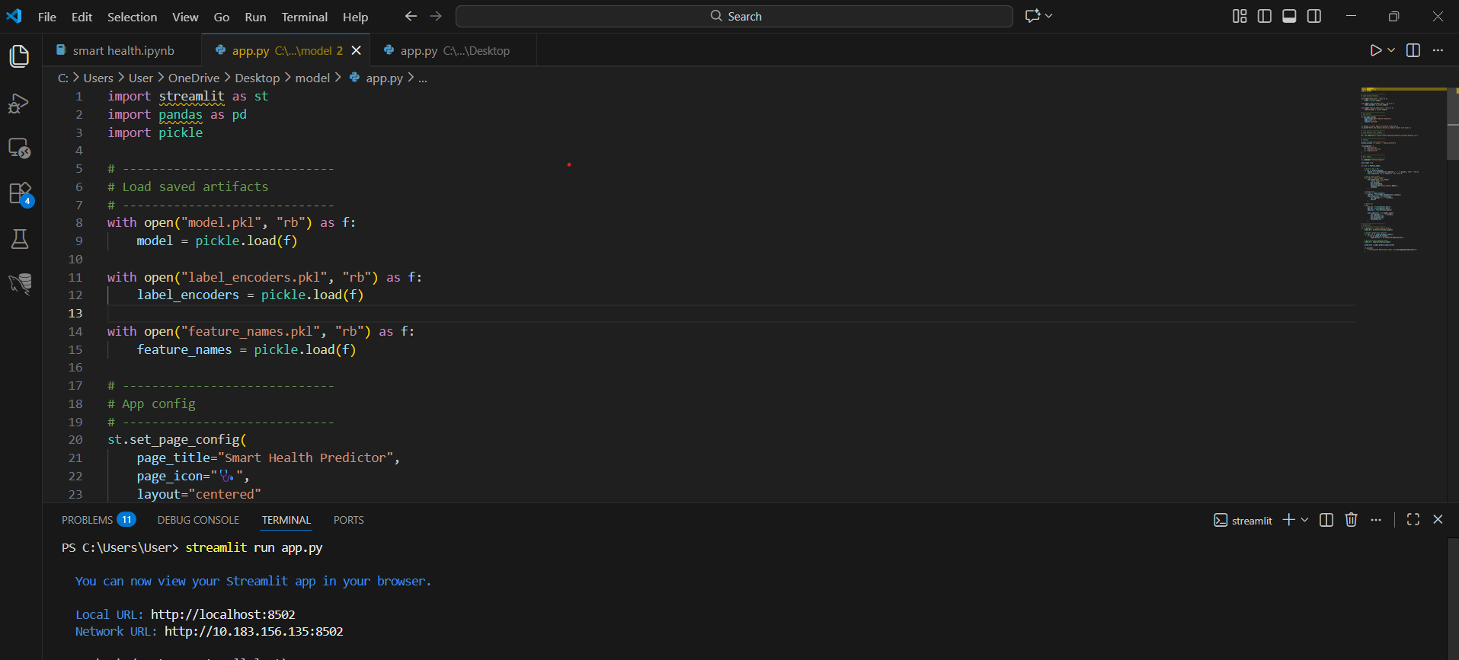

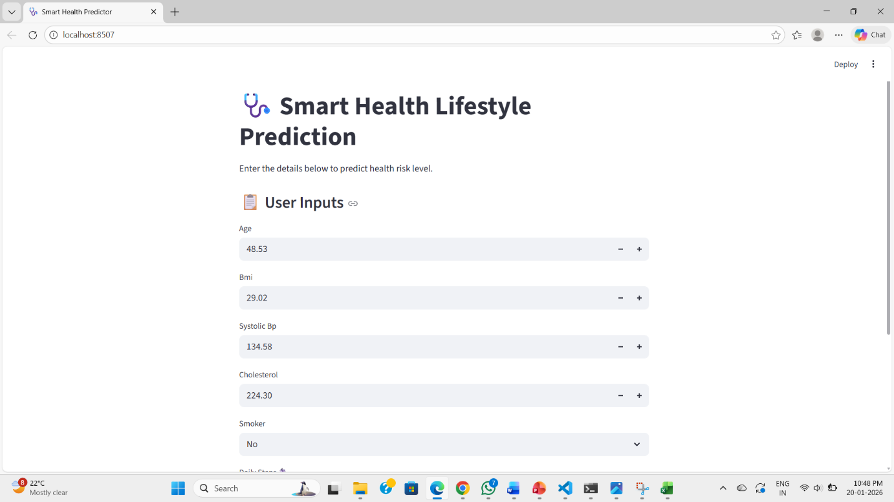

11.2 Prediction Output and Confidence Score
The system outputs loan approval status along with a confidence score indicating prediction certainty.
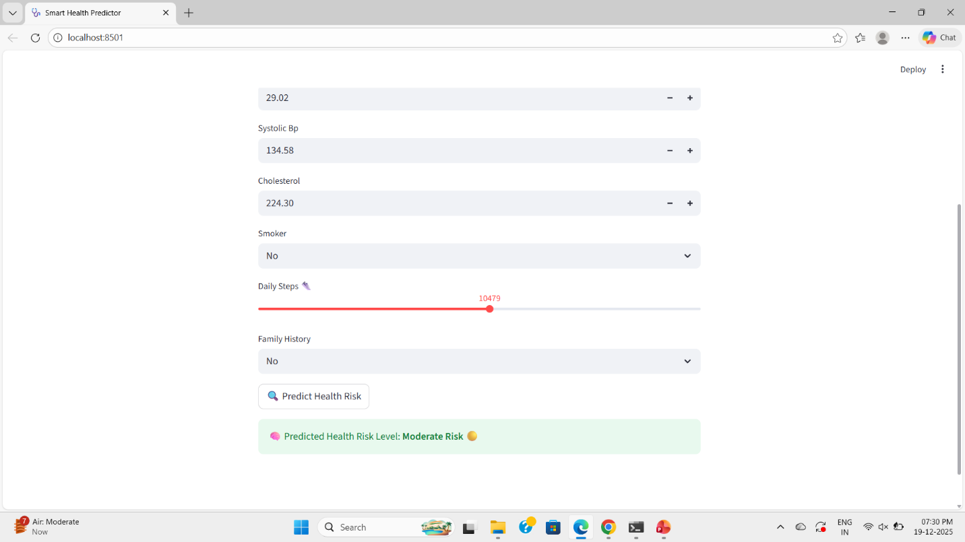
11.3 Result Analysis
The results are analyzed to verify accuracy, reliability, and effectiveness of the model.

11.4 Input and Output Screens
Users input data and receive instant loan approval results with confidence scores.

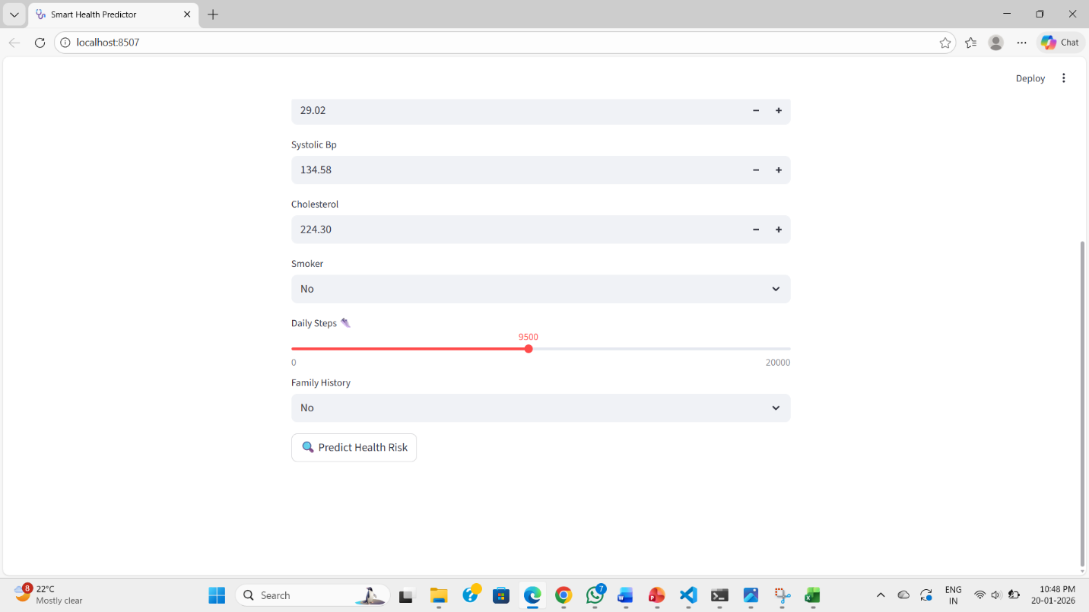

CHAPTER 12 – CONCLUSION AND FUTURE SCOPE

12.1 Summary of the Project
This project successfully implements an intelligent and explainable loan approval system using Machine Learning.

12.2 Key Achievements
- Automated loan approval
- High prediction accuracy
- Transparent decision-making
- User-friendly interface

12.3 Future Enhancements
Future work includes advanced ML models, SHAP explanations, cloud deployment, and real-time banking integration.

REFERENCE :-
- Tom M. Mitchell, Machine Learning, McGraw-Hill, 1997.
- Aurélien Géron, Hands-On Machine Learning with Scikit-Learn, Keras, and TensorFlow, O’Reilly Media, 2019.
- Ian Goodfellow, Yoshua Bengio, Aaron Courville, Deep Learning, MIT Press, 2016.
- Scikit-learn Documentation, Gradient Boosting Classifier.
- Kaggle, Health and Lifestyle Datasets.
- J. Han, M. Kamber, J. Pei, Data Mining: Concepts and Techniques, Morgan Kaufmann, 2011.
- World Health Organization (WHO), Health Statistics and Reports.
- UCI Machine Learning Repository, Healthcare-related Datasets.

Course Outcomes (CO’s):
Course Outcome (CO) | CO Statement
CO1 | Understand the challenges and limitations of traditional loan approval systems and the need for automation and transparency in banking applications.
CO2 | Apply data preprocessing techniques such as data cleaning, feature selection, and normalization on real-world financial datasets.
CO3 | Design and implement a supervised machine learning model using Logistic Regression for binary classification problems in loan approval.
CO4 | Analyze and interpret model outputs using Explainable AI concepts to understand the influence of financial attributes on loan approval decisions.
CO5 | Develop a user-friendly web-based application using Streamlit to provide real-time loan approval predictions with confidence scores.
CO6 | Evaluate the performance of the proposed system using appropriate metrics and assess its reliability, fairness, and scalability in banking scenarios.

Supported Program Outcomes (Po's) And Sustainable Development Goals (SDG's):
Program Outcomes (PO’s):
The following are 8 program outcomes
PO No. | Program Outcome Description
PO1 | Apply knowledge of mathematics, statistics, machine learning, and computer science fundamentals to solve real-world banking and financial problems.
PO2 | Analyze loan approval challenges such as bias, inefficiency, and lack of transparency, and formulate suitable AI-based solutions.
PO3 | Design and develop an intelligent, explainable, and scalable loan approval system that meets functional, ethical, and regulatory requirements.
PO4 | Conduct experiments, analyze financial datasets, and interpret model results to validate accuracy and reliability of predictions.
PO5 | Use modern tools and technologies such as Python, Scikit-learn, and Streamlit to implement and deploy machine learning applications.
PO6 | Understand ethical responsibilities including fairness, transparency, accountability, and bias mitigation in AI-driven financial systems.
PO7 | Communicate technical concepts, system architecture, and results effectively through reports, presentations, and demonstrations.
PO8 | Recognize the need for lifelong learning and adaptability to emerging technologies in Explainable AI and FinTech domains.

Sustainable Development Goals (SDG's):
SDG 1 | No Poverty | SDG 10 | Reduced Inequalities
SDG 2 | Zero Hunger | SDG 11 | Sustainable Cities and Communities
SDG 3 | Good Health and Well-being | SDG 12 | Responsible Consumption and Production
SDG 4 | Quality Education | SDG 13 | Climate Action
SDG 5 | Gender Equality | SDG 14 | Life Below Water
SDG 6 | Clean Water and Sanitation | SDG 15 | Life on Land
SDG 7 | Affordable and Clean Energy | SDG 16 | Peace, Justice and Strong Institutions
SDG 8 | Decent Work and Economic Growth | SDG 17 | Partnerships for the Goals
SDG 9 | Industry, Innovation and Infrastructure
The following are 17 Sustainable Development Goal

